Our Mission Statement  Our Most Popular Games!  - Chocolate Crush  - Angry Cows  - Beat the Blast  - Mystery Detective  - Sports, Sports, Sports! |  |  | Recipient Name  Address  City, ST ZIP Code  Game Shop  1234 Geek Road  Video City, UT 84123 |  | Game Shop  We specialize in custom flavors!  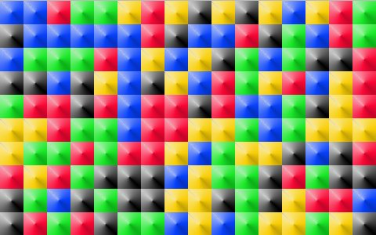

  More Than a Game Store  Do you want more from your computer game store? Do you want to meet other gamers, make new friends, and play games with them face-to-face so you know who they are when you are online?  Game Shop specializes in creating a unique gaming community. We know how to have fun and we want to share our fun with you.  Safer Gaming  Don’t game with strangers online! Come make new friends at our monthly game nights and know who you are playing with when you meet again online. | Monthly Birthday Club:  Enroll in our birthday club to participate in a free gaming night during your birthday month. We even provide the ice cream!  We will also teach you tips and tricks for playing popular games. Our employees are not just here to sell you games … they also play games! And during our game nights our players teach each other.  Our Guarantee  We are so sure you’ll love your gaming experience with us that we will give you a free game of your choice if you try us at least three times and still don’t like us. So what do you have to lose? Come join us. |  | Our Shop is Fun!  Our shop is so fun, our customers come back over and over again. What makes us different from other game stores?  - Our employees dress like game characters  - We don’t just sell games, we play them!  - Our monthly gaming nights  More of Our Most Popular Games!  Gone Fishing  Zombie Zapper  Jawbreaker  Don’t Take My Phone Away!  Cars on Mars  Contact Us  Game Shop  1234 Geek Road  Video City, UT 84123  (801) 123-4578

